**GODADDY WEB Build-a-thon Project Report**

ON

**“FOOD AND DRINKS WEBSITE ”**

Submitted for the GODADDY WEB build-a-thon of

**Machine Learning**

BY

**NAME: RAHUL P.BHERE**

**A project report submitted to:**

Smart Bridge



**ACKNOWLEDGMENT:**

The success and outcome of this project required guidance and assistance from **Smart Bridge**. I am extremely privileged to have got this all along with the completion of my project. All that I have done is only due to such supervision and assistance and I would not forget to thank them. I thank **Smart Bridge**, for providing me an opportunity to do the project work in the GODADDY WEB build-a-thon **FOOD AND DRINKS WEBSITE** and giving me all support and guidance which made me complete the project duly. I am extremely thankful to smart bridge for providing such a nice support and guidance.

**1 INTRODUCTION**

This project starts with a high-level overview of the project. It then describes the specific aims and objectives of the project. Finally, it analyses the feasibility of the project and provides with a feasibility report of the system.

**1.1 Overview**

The project sets to develop an online ordering system for restaurant. Many industries now quickly adopting technologies. Restaurant industry also embraces different types of technologies which make daily processes easier and faster. But the adoption of technology in restaurant industry is slower compared to other industries (Saeed et al., 2016). Restaurants can use technology in different ways.“FOODIE RESTAURANT” management website is a web, tablet and mobile application. This system is developed to automate day to day activity of a restaurant. Restaurant is a kind of business that serves people all over world with ready-made food. This system is developed to provide service facility to restaurant and also to the customer. This restaurant management system can be used by employees in a restaurant to handle the clients, their orders and can help them easily find free tables or place orders.

**1.2 Purpose**

The main point of developing this website is to help restaurant administrator manage the restaurant business and help customer for online ordering and reserve table. In proposed system user can search for a menu according to his choice i.e. according to price range and category of food and later he can order a meal.

  The services that are provided is food ordering and reservation table management by the customer through the system online, customer information management and waiter information management, menu information management and report. The restaurant menu is organized by categories (appetizers, soups, salads, entrees, sides and drinks) of menu items. Main objective to build the website is to provide ordering and reservation service by online to the customer. Each menu item has a name, price and associated recipe. A recipe for a menu item has a chef, preparation instruction sand associated ingredients. With this website online, ordering and reservation management will become easier and systematic to replace traditional system where are still using paper.

**LITERATURE SURVEY**

**Existing Problem**

* The main problem which we face today is seat availability on a particular time
* The ambiance check for particular occasion.
* Is the food of our preference available?
* Reservation for a pre planned event.
* Number of cuisine available in a particular place.
* Unable to pre plan budget.
* Lack of Contact information of the place.

**Proposed Solution**

* Our website has answers to all of the questions above
* One can check for seat availability before coming to the restaurant.
* Can check our food description and ambiance in a detailed way on our website
* Can check if the food of our choice present on a particular day.
* Reservations for a pre-planned event are available
* We have all cuisines at one place with detailed description on our website
* Can have an approximate idea on the budget.

**THEORITICAL ANALYSIS**

**Block Diagram:**

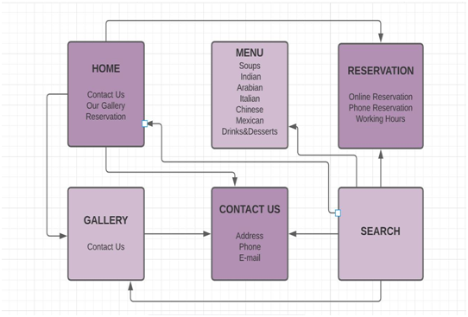

**Software and Hardware:**

**1.software:**

Theme used: Ocean WP

Plug-ins used: Ocean Extra and elementor .

**2.Hardware:**

64 bit Laptop

**EXPERIMENTAL INVESTIGATIONS:**

By interviewing many people from different age groups, different professions and random individuals we got to know that having a website for a restaurant would be really helpful in many ways.

It overcomes the problems of unavailable seats, incorrect guessing of prices and irrelevant place for different occasions.

**FLOWCHART:**

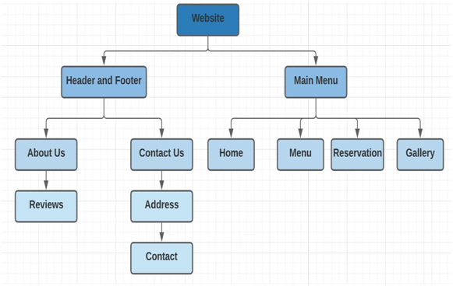

**RESULT:**

This is the final outcome of my website. This is a responsive and very user friendly website.

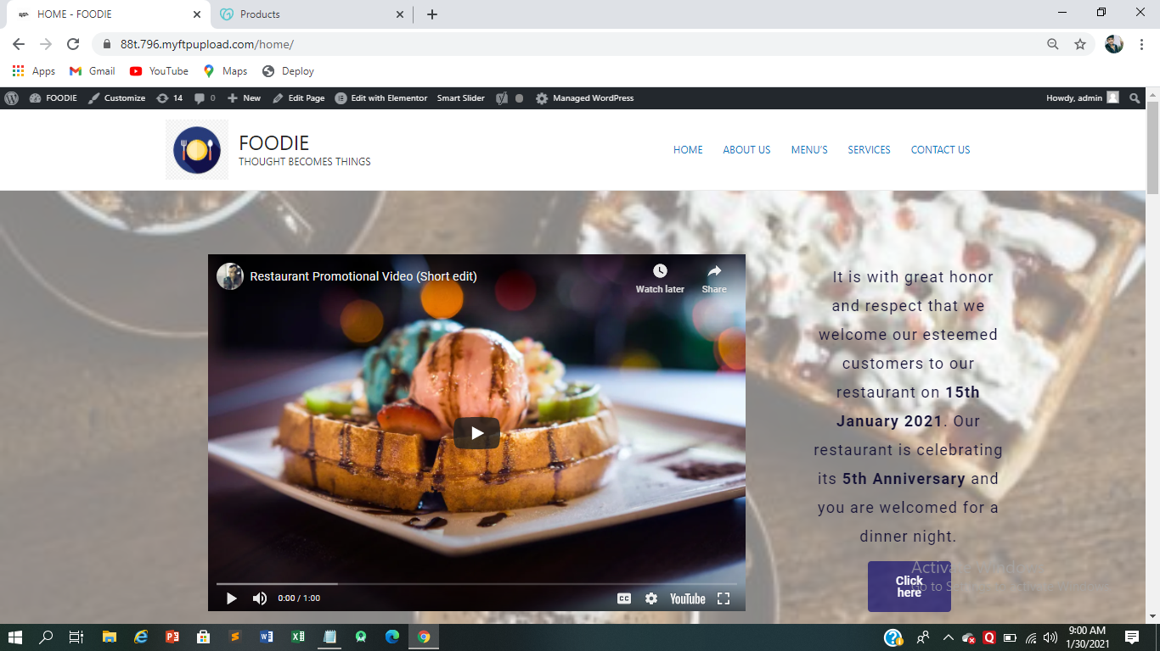

**ADVANTAGES & DISADVANTAGES:**

**Advantages:**

1. Reservations

This is the most helpful feature in the website because reserving a table without an online booking feature through phone would be very hectic and time taking process.

1. Ambiance check

This tab helps to pre check the place whether it suits your occasion or not

1. Preference of food

Every individual has different food preferences and having an online visible menu would help customers decide whether to choose this place on a particular day.

1. Seat availability

Sometimes we go to a restaurant with large group of friends/family and unfortunately many a times we have longer waiting periods to get seat for such a large group, so checking seat availability before coming to place would really save a large amount of time.

1. Location

This is useful to check the travel time and traffic in the way.

1. Accommodation for number of people

We can check how big the place is and the ambiance of the place through the gallery photos.

1. Budget.

The online menu helps us to decide the price for individual for lunch/breakfast/dinner.

1. All cuisines – one place

As Iyava Bistro has all cuisines at one place, the detailed information about this is given in the website

It is present on the internet and accessible to everyone.

**Disadvantages:**

The only disadvantage is one should have access to internet only then he/she can access the website and know about the website.

**APPLICATIONS:**

It has online presence round the clock

Information exchange between customer and management can be done easily

Customer can get insights about the place in an easy way

**CONCLUSION:**

Finally we can conclude that this website has various advantages to all type of customers by giving the information they need before visiting the actual place. I believe having an website to every restaurant makes life easier by saving time, effort and money.

**FUTURE SCOPE:**

As we know the online food ordering system is one of the most businesses. We can include this feature in future to our website. We also prevent missed orders due to busy phone lines or missed phone call. As the face of the restaurant industry is shifted from the traditional dine-in culture to takeaways, online ordering, and home deliveries. We can also incorporate mobile food ordering app in our restaurant management system to streamline the entire order taking process.

**BIBILOGRAPHY:**

I collected the food pictures from a website: https://www.foodie.com/

I referred to a few restaurant websites for reference for my website.